
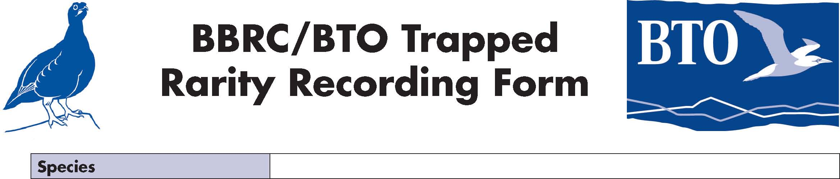
BBRC/BTO Trapped
Rarity Recording Form

Species

Ring number |  | Date of capture
Age / sex |  | Time of capture and release
Name / email of ringer (and ringer in charge if different) |  | Location
Other observers |  | First and last dates

Wing length
Biometrics
Tail length
Bill (to skull)
Bill (to feather)
Tarsus
Weight
Fat
Muscle
Previous experience of the observers (in the hand and in the field)

 | Measurement (length relative to longest PP) | Emargination / notch (with measurement if required)
1
Wing formula
2
3
4
5
6
7
8
9
10
Longest PP-SS
Length P1-PC

Reason for identification, ageing and sexing, including pattern and extent of moult
It is assumed that submissions will be accompanied by digital photos, so only brief notes are required. Birds without photos should be accompanied by details of all plumage.

Brief circumstances of finding

This form should be submitted to both your county recorder (see www.britishbirds.co.uk/countyrecorders.htm) AND to the BBRC (secretary@bbrc.org.uk), and copied to the BTO (ringing.licensing@bto.org). Ringing details should be submitted to the BTO as per normal, who will liaise with BBRC on acceptance.

